IMD Global PSI iOS app

Technical Documentation

**General Description**IMD Global PSI is an application that shows PSI Singapore data in map and chart.

**Features**

* Select PSI data by date
* Shows marker on map
* Shows chart per region
* Shows up to date information data per region

**Developer Environment**

IDE using XCode 8.3

Language using Swift

**Library Used**

* Moya for network manager
* CircularSpinner for loading placeholder
* SwiftyJSON for json parser
* SCLAlertView for custom alert view
* Charts for showing data on chart

**Classes**

1. **Provider**

* PSIDataProvider

1. **Models**

* PSIData
* RegionMetadata
* Items
* Location

1. **View Controller**

* PSIMapVC
* PSIDetailsVC

**User Interface**

**Map View**

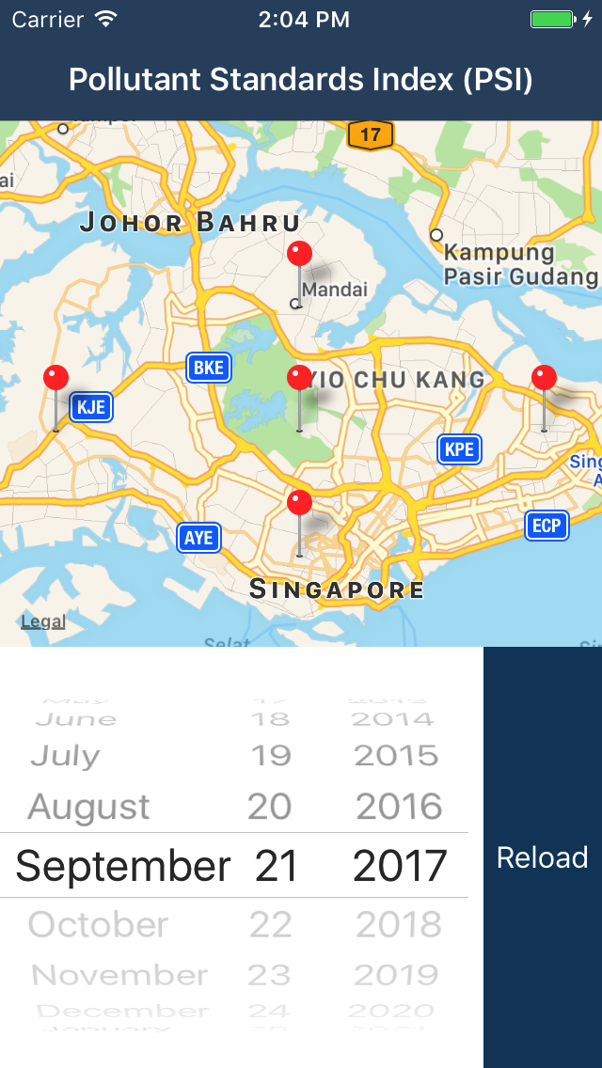 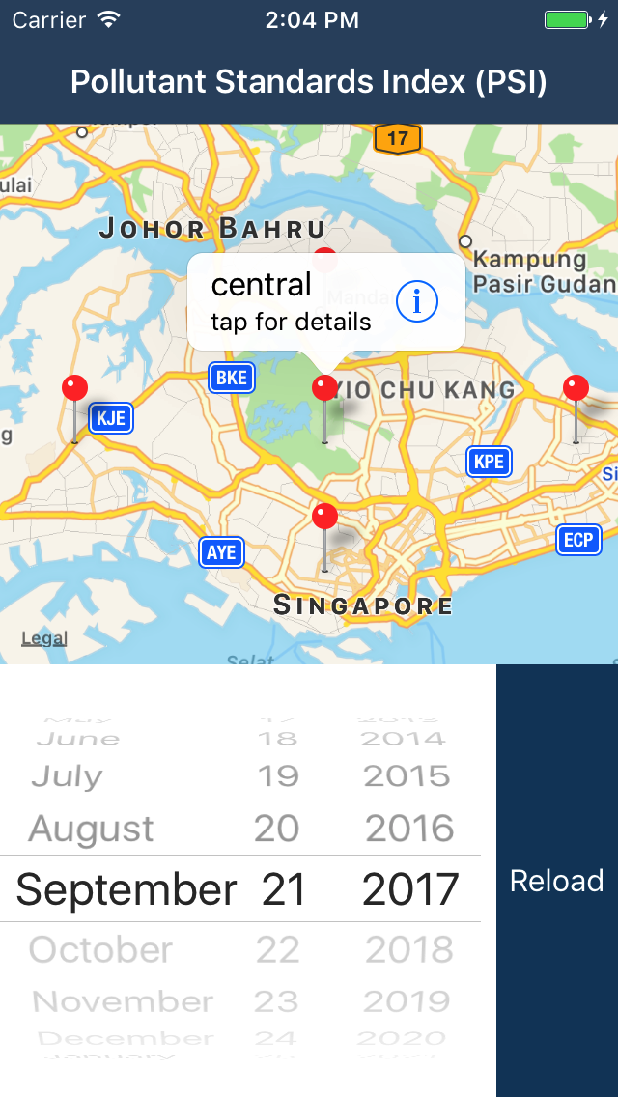

**Chart and Table View**

